**1. Introduction:**

The DHT11 is chosen because it is lab calibrated, accurate and stable and its signal output is digital. Most important of all, it is relatively inexpensive for the given performance. Below is the pinout of the sensor.

**2. Understanding DHT11 sensor**

DHT11 sensor gives humidity and temperature data. It has got following pin interface.

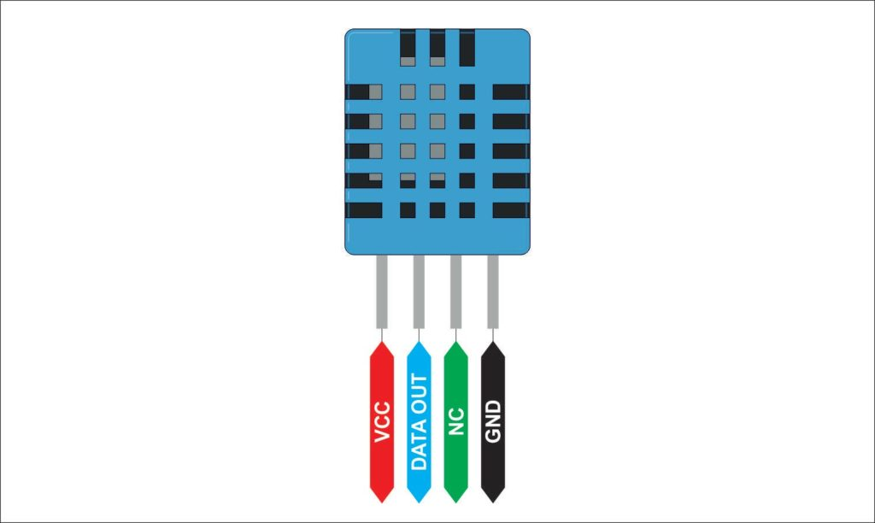

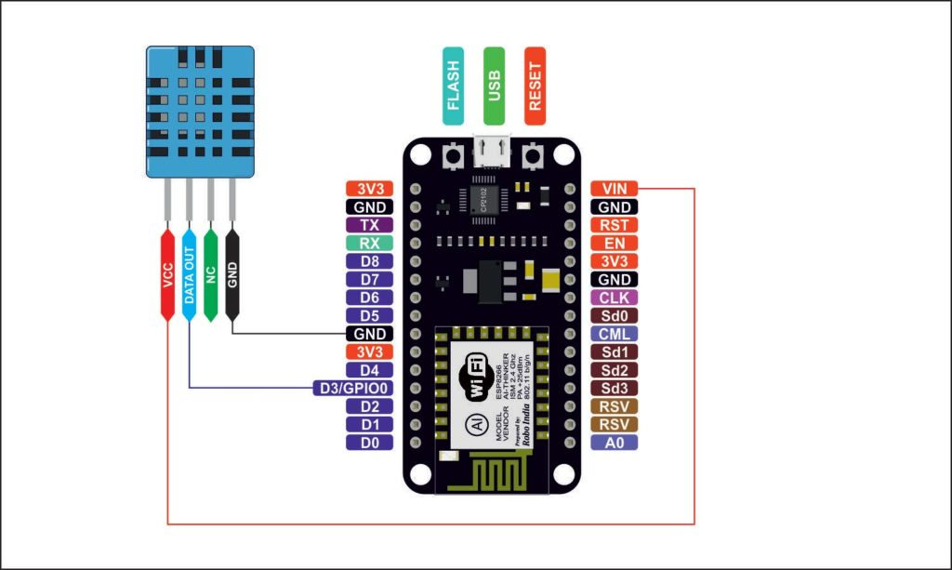

**3. Circuit**

Make the following connections –

**4. Library File**

*Following two libraries will be required to run this code*. Download the zip file extract the same and copy this to your Arduino library folder.

This library file should be placed at the install folder of Arduino. I have a 64 bit Win7 OS and my arduino library folder address is located at

*C:\Program Files (x86)\Arduino\libraries*

[Library 1 : You may download library file from here.](https://roboindia.com/tutorial-content/arduino_code/Adafruit_Sensor-master.zip)

[Library 2: You may download library file from here.](https://roboindia.com/tutorial-content/arduino_code/DHT_sensor_library.zip)

**5. Programming**

#include "DHT.h"        // including the library of DHT11 temperature and humidity sensor

#define DHTTYPE DHT11   // DHT 11

#define dht_dpin 0

**DHT** dht(dht_dpin, DHTTYPE);

void setup(void)

{

 dht.begin();

**Serial**.begin(9600);

**Serial**.println("Humidity and temperature\n\n");

 delay(700);

}

void loop() {

   float h = dht.readHumidity();

   float t = dht.readTemperature();

**Serial**.print("Current humidity = ");

**Serial**.print(h);

**Serial**.print("%  ");

**Serial**.print("temperature = ");

**Serial**.print(t);

**Serial**.println("C  ");

 delay(800);

}

**6. Output**

Upload the above code to the NodeMCU and open serial monitor. Following output should be shown on the serial monitor.